**Electronic Gadgets Task 3**



SELECT o.OrderID, o.OrderDate, o.TotalAmount,

c.CustomerID, c.FirstName, c.LastName, c.Email, c.Phone

FROM Orders o

JOIN Customers c ON o.CustomerID = c.CustomerID;



SELECT p.ProductName, SUM(od.Quantity * p.Price) AS TotalRevenue

FROM OrderDetails od

JOIN Products p ON od.ProductID = p.ProductID

GROUP BY p.ProductID, p.ProductName

ORDER BY TotalRevenue DESC;



SELECT DISTINCT c.CustomerID, c.FirstName, c.LastName, c.Email, c.Phone, c.Address

FROM Customers c

JOIN Orders o ON c.CustomerID = o.CustomerID;



SELECT p.ProductName, SUM(od.Quantity) AS TotalQuantityOrdered

FROM OrderDetails od

JOIN Products p ON od.ProductID = p.ProductID

GROUP BY p.ProductID, p.ProductName

ORDER BY TotalQuantityOrdered DESC

LIMIT 1;



ALTER TABLE Products ADD COLUMN Category VARCHAR(50);

UPDATE Products

SET Category = 'Laptop' WHERE ProductName = 'Laptop';

UPDATE Products

SET Category = 'Smartphone' WHERE ProductName = 'Smartphone';

UPDATE Products

SET Category = 'Audio Accessories' WHERE ProductName IN ('Headphones', 'Speakers');

UPDATE Products

SET Category = 'Computer Accessories' WHERE ProductName IN ('Keyboard', 'Mouse', 'Monitor');

UPDATE Products

SET Category = 'Storage Devices' WHERE ProductName = 'External HDD';

UPDATE Products

SET Category = 'Office Equipment' WHERE ProductName = 'Printer';

UPDATE Products

SET Category = 'Tablets' WHERE ProductName = 'Tablet';



SELECT c.CustomerID, c.FirstName, c.LastName, AVG(o.TotalAmount) AS AvgOrderValue

FROM Customers c

JOIN Orders o ON c.CustomerID = o.CustomerID

GROUP BY c.CustomerID, c.FirstName, c.LastName

ORDER BY AvgOrderValue DESC;

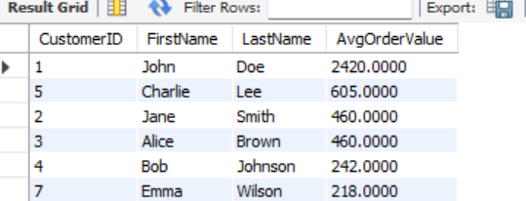



SELECT o.OrderID, c.CustomerID, c.FirstName, c.LastName, c.Email, o.TotalAmount AS TotalRevenue

FROM Orders o

JOIN Customers c ON o.CustomerID = c.CustomerID

ORDER BY o.TotalAmount DESC

LIMIT 1;





SELECT p.ProductName, COUNT(od.OrderID) AS TimesOrdered

FROM OrderDetails od

JOIN Products p ON od.ProductID = p.ProductID

GROUP BY p.ProductID, p.ProductName

ORDER BY TimesOrdered DESC;

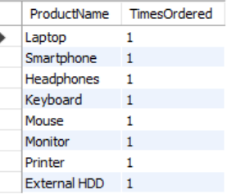



SELECT DISTINCT c.CustomerID, c.FirstName, c.LastName, c.Email

FROM Customers c

JOIN Orders o ON c.CustomerID = o.CustomerID

JOIN OrderDetails od ON o.OrderID = od.OrderID

JOIN Products p ON od.ProductID = p.ProductID

WHERE p.ProductName = 'Laptop';





SELECT SUM(TotalAmount) AS TotalRevenue

FROM Orders

WHERE OrderDate BETWEEN '2024-01-01' AND '2024-12-31';